**DISTRIBUTION OF SUPPORT PRODUCTS TO PERSONS WITH ALBINISM IN KENYA**

Presented by,

1. Glendah Moraa
2. Ian Gathumbi
3. Caleb Muinde
4. James Muguro
5. Naman Hirani

**BUSINESS UNDERSTANDING**

**Introduction**

Albinism is a rare skin condition where there is little or no production of melanin that results in one’s skin, hair or eyes to have little or no colour. It is caused by a genetic disorder in one of several genes that produce or distribute melanin. This means that it is an inherited disorder that is present at birth and so children with parents with albinism or parents who carry the gene for albinism are at high risk of having the condition.

The main symptom is little or no colour in one’s skin, hair or eyes. Melanin protects the skin from damage by ultraviolet rays from the sun and people with albinism lack that protection. As a result, they may suffer from sunburn, develop freckles, moles, lentigines and more worryingly they are more susceptible to skin cancer. Moreover, they may develop vision problems such as extreme short or long sightedness, poor depth perception, sensitivity to light and even complete blindness.

Albinism has no cure and therefore has to be managed by using sunscreen and protective clothing to protect the skin from harmful UV rays, use of sunglasses or prescription glasses for the eyes.

As for the situation in Kenya for people with albinism, medical research in 2017 found some types of cutaneous malignancies are common suggesting a lack of access to sunscreen and protective clothing. To try to remedy this, the National Albinism Sunscreen Support Program (NASSP) was set up to procure and distribute sunscreen lotions for persons with Albinism through the National Council for Persons with Disabilities (NCPWD) and the Kenya Medical Supplies Authority. They were to do this by distributing support products such as sunscreens, sun lotions, clothing etc. to all level 4 and 5 hospitals in all counties with persons with Albinism

**Problem statement**

In recent years, Kenya has generally been considered to be a country that is safer for persons with Albinism within the East African community, a good indicator being Isaac Mwaura who became the first Kenyan Albinism to join parliament in 2013. The government has put across measures to improve the health standards of persons with albinism following the recommendation stated in a report from a research conducted in the year 2017. As by the report, it was clearly stated that there was lack of access to healthcare, more particularly medical checkups and appropriate sunscreen to persons with albinism. The government was also using an estimated number of persons with albinism to distribute the sunscreen which was not reliable.

As stated in the previous paragraph, the government using the unreliable estimate to distribute health products probably affected a certain percentage of persons with Albinism. In the vision 2030, the government promised to “leave no one behind” and committed to start with “the further behind first”. The persons with albinism are among the further behind, having been left out of discourses on gender, disability and more especially on color that is intersecting their identities that are part of life with albinism. A survey was then conducted and the government went ahead and updated the new number of persons with albinism on 20th June 2018 to improve the distribution of support products across the country.

It is vital for the government to ensure equal distribution of the support products and also to include measures to ensure that the sunscreen provided is appropriate. Therefore, this project aims at drawing insights that will be used to optimize the distribution of sunscreen and support products to persons with albinism over the counties and countrywide.

**Proposed solution.**

Use of data analysis to ensure equitable distribution of sunscreen and support products to persons with albinism across the counties and countrywide

**Research Objectives**

General objective

* Analyzing the distribution of sunscreen and support products to persons with albinism in all counties in the country

Specific objectives

* To determine the total and average distribution for products
* To establish whether the county with the highest number of PWA is the one that received the highest distribution of sunscreen and support products.
* To access whether the county with the lowest number of PWA is the one that received lowest distribution of sunscreen and support products
* To establish whether the counties with the highest number of PWA is the one that has the highest of health care centers

**Research Questions**

* What is the distribution of sunscreen and support products to persons with albinism in all counties in the country?
* What is the total /average distribution for products?
* Does the county with the highest number of PWA receive the highest distribution of sunscreen and support products?
* Does the county with the lowest number of PWA receive the lowest distribution of sunscreen and support products?
* Does the county with the highest number of PWA have the most health care centers?

**Analysis Questions**

1. What are the total products for each product that were distributed per county?

Explanation:

To get the sum on the distribution of each product we use group by

2. What is the total number of products that was distributed overall per county (2018)?

3. How many products were distributed (2018)

4. What is the average distribution overall

5. The total number of PWA (2018)

6. The total number of PWA (2019)

7. The total percentage increase for PWA

8. What is the average distribution for each product per product?

9. The total number of products distributed per county

10. Which 5 counties have the highest number of PWA (2018)?

11. Which 5 counties have the highest distribution of sunscreen and support products?

12. Which 5 counties received the highest number of Long Sleeved T Shirts?

13. Which 5 counties has the highest number of PWA (2019)

14. The percentage increase of PWA per county

15. Which 5 counties have the lowest number of PWA?

16. Which 5 counties have the lowest number of PWA?

17. Which 5 counties received the highest number of Lip Care?

18. The county with the lowest number of PWA

19. The counties with the highest number of health care centers.

20. The estimated number of sunscreen lotions per county

21. The estimated number of Lip Care per county

22. The estimated number of AfterSun Lotions county

23. The estimated number of Caps per county

24. The estimated number of Long Sleeved T Shirts per county

25. The estimated Total distribution per county

**Justification**

The purpose of this project is to examine whether distribution of sunscreen, lotions, hats, sunglasses, sun-protective clothing and other support services to people living with albinism by national and county governments is equitable and sufficient. Though people with albinism represent a relatively small segment of the population, they are disproportionately affected by poverty. Moreover, they face multiple and intersecting forms of discrimination on the grounds of disability and colour, and are often excluded from public policies in the key areas of health and education. The expectation is that this project will prompt much-needed research, data collection, and discussion on issues affecting people with albinism so that progress may be made in the respect, protection, and fulfilment of their human rights.

A very basic human need is to be “seen” “by another person-to be known and to be accepted. This is poignantly true for the person with albinism who may be immediately “noticed” by many, but truly “seen” by few. The data collected through this project have the potential to be used to raise awareness against all forms of discrimination, whether by the government, communities, or family, and including multiple and intersectional discrimination. Furthermore, the project results may provide the government with information that potentially can be used to address the medical and support needs of people living with albinism through identifying, prohibiting, preventing, and eliminating inequality.

**Assessing the situation**

Resource inventory

1. Distribution Of Sunscreen And Support Products To Persons With Albinism (PWA's) Dataset: [[Link]](https://drive.google.com/file/d/1-Y1va3dS_96to_lJupOeZ5C6QV6Uo0lE/view?usp=sharing)
2. Distribution of Persons with Albinism by Sex, Area of Residence, County and Sub County 2019 Census Volume IV: [[Link]](https://drive.google.com/file/d/1NuWGq5fvzSDpNsAUSCrqWunt361XcuY1/view?usp=sharing)

Software: Pandas, Google Collaboratory and Github, JIRA

Assumptions.

Data provided is relevant and correct

Constraints.

There are no limitations in the analysis.

**Project plan**

The project plan can be found at jira: [[Jira Link]](https://35192790.atlassian.net/jira/software/projects/AP/boards/4)

**DATA UNDERSTANDING**

**Data understanding overview**

In this project we are only going to use the datasets that are available.

* Distribution of sunscreen and support products to PWA [[Link]](https://drive.google.com/file/d/1-Y1va3dS_96to_lJupOeZ5C6QV6Uo0lE/view?usp=sharing)
* Distribution of persons with Albinism [[Link]](https://drive.google.com/file/d/1NuWGq5fvzSDpNsAUSCrqWunt361XcuY1/view?usp=sharing)

**Data description**

Below is a detailed description of the available dataset.

* Distribution of sunscreen and support products to PWA - This dataset has information of the distribution of various products i.e. sunscreen lotions, aftersun lotions, caps, long sleeve t-shirts, lip care products and the numbers of PWA in the year 2018 in each county.
* Distribution of persons with Albinism - This dataset has information on the population of people in the country/county and the number of PWA in the year 2019,

**DATA PREPARATION**

Loading data

We uploaded our data sets onto Google colaboratory and created dataframes *products* and *population.*

Cleaning data

*Dataframe : products*

We dropped irrelevant columns such as 'Financial_Year_Ending', 'Centroid_x', 'Centoid_Y', 'OBJECTID' as they were irrelevant to our analysis.

To confirm the accuracy of the data we confirmed if the number of counties were 47 and they were.

There were null values which were dropped from our data frame. Moreover, we checked for duplicate records which there were none.

Lastly, we changed the column names to 'County', 'Health_Centres', 'No_(PWA)_2018', 'Sunsreen_Lotions', 'Lip_Care', 'AfterSun_Lotions', 'Caps', 'Long_Sleeved_Tshirts'

*Dataframe : population*

We stripped the commas from the 'Total Population', ‘Male’ and ‘Female’ columns so as to convert the column types to integers later on.

There were no duplicate records in our dataframe but there were null values which we dropped.

We changed the column names to 'County/Sub_County', 'Total_Pop', 'Male_Pop', 'Female_Pop', 'No_PWA()_2019', 'Total_Male_PWA', 'Total_Female_PWA'

Merging data

For us to merge *products* and *population* on 'County' and 'County/Sub_County' respectively we had to modify our data frames.

For the *products* dataframe we created a new data frame *ProductsCounty* from it by grouping by 'County' to show the distribution of products by county.

We also corrected the county names from *ProductsCounty.*

The *population* data set had counties and sub counties on the same column and we needed the counties only. To do this we created a list with all the counties in Kenya and matched them to the 'County/Sub_County' column to extract the counties from *population.* We named the resulting data frame *PopCounty.*

Some counties and sub counties share similar names and therefore appeared in *PopCounty.* We dropped these sub counties with the drop_duplicates function.

Finally we merged the data frames *ProductsCounty* and *PopCounty* to create a new data frame *merged_df* for our analysis

**DATA ANALYSIS**

In 2018 there were a total of 3153 registered people with albinism but 2019 census data showed the total number was actually 9738.

What is the distribution of sunscreen and support products to persons with albinism in all counties in the country?

The distribution in all counties can be found in the following [[Link]](https://drive.google.com/file/d/16vyY98d-23R2LK3qCAWvzFYuTV-dBgkO/view?usp=sharing)

## What is the total and average distribution of products?

## A total of 397,278 support products were distributed in 2018 with each county receiving 8453 products on average.

The average distribution for each product per county was:

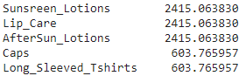

Does the county with the highest number of PWA receive the highest distribution of sunscreen and support products?

The counties with the most number of PWA in 2018 were:

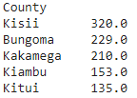

The counties with the most number of PWA in 2019 were:

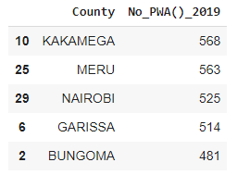

The counties that received the most support products were:

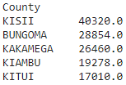

Does the county with the lowest number of PWA receive the lowest distribution of sunscreen and support products?

The counties with the lowest number of PWA in 2018 were:

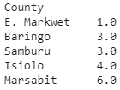

The counties with the lowest number of PWA in 2019 were:

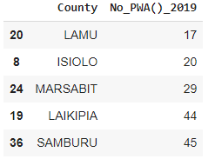

The counties that received the least support products were:

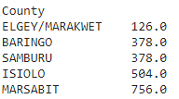

Does the county with the highest number of PWA have the most health care centers?

Counties with the most health care centers were:

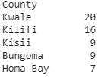

Counties with the least health care centers were:

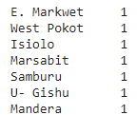

What is the distribution of PWA by gender?

There were 4469 males with albinism and 5268 females with albinism in 2019

VISUALIZATION.

1. A bar graph to cho the increase in number of persons with albinism in the 2018/2019,

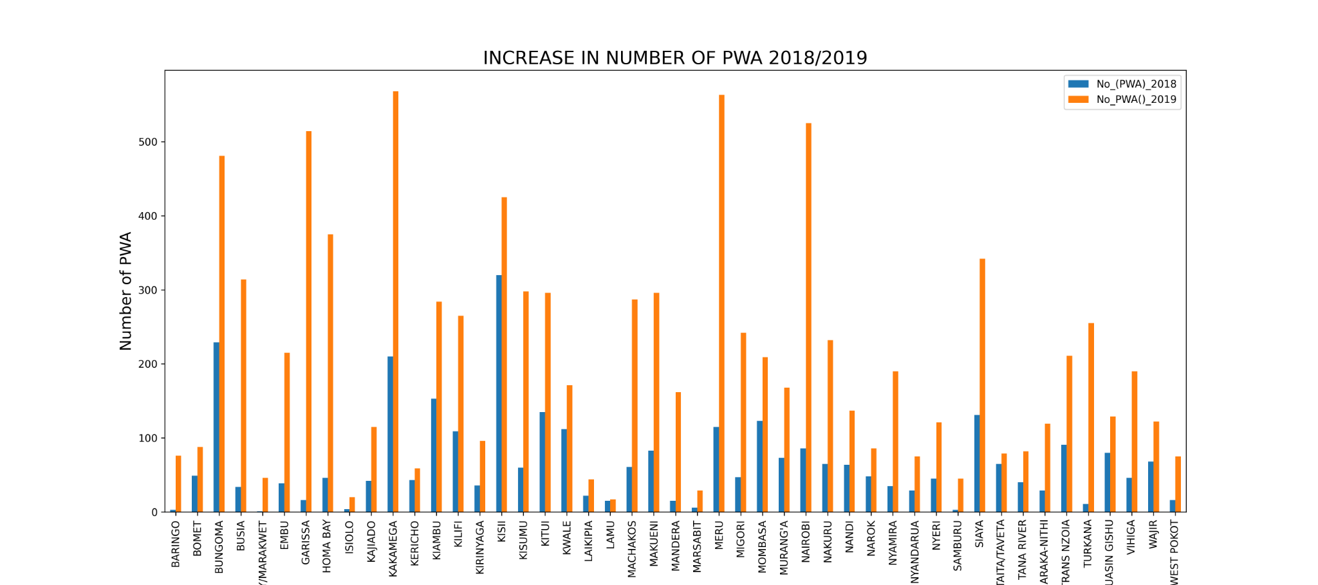

1. A line graph to show the estimation of the products that should be distributed

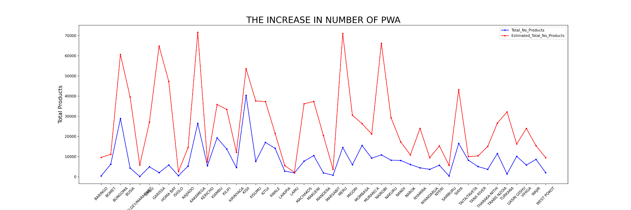

1. A Pie showing the total distribution per production
2. 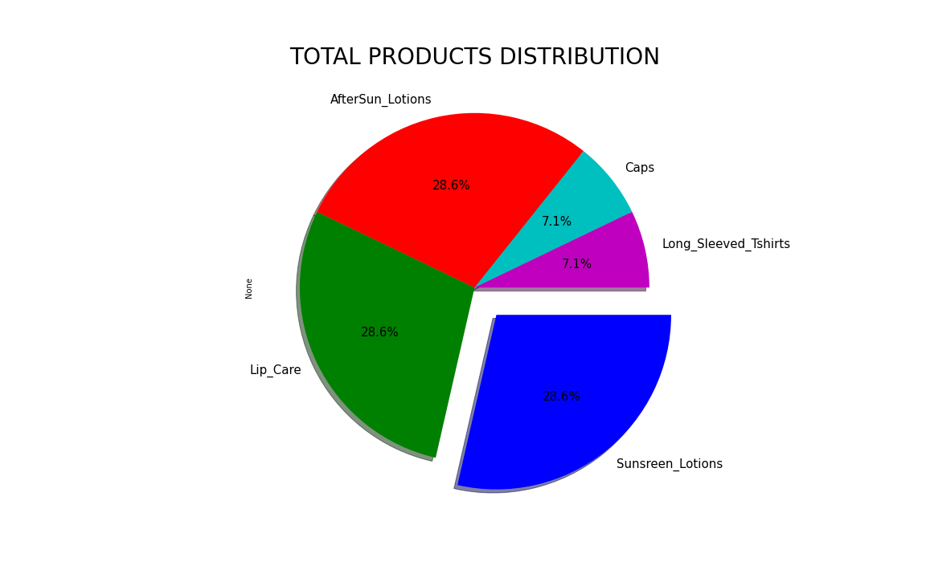

4. A pie chart showing the percentage of people with Albinism by Gender

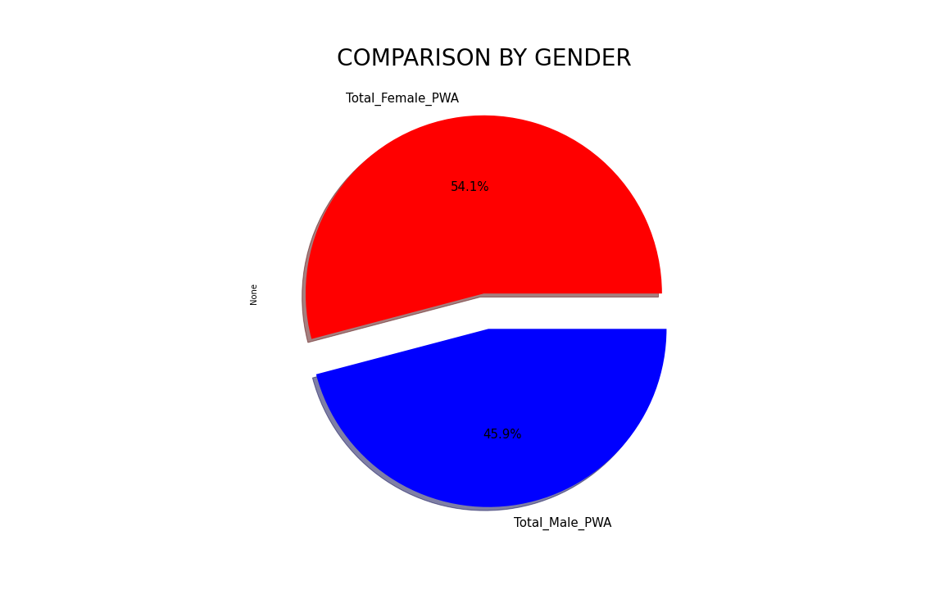

**RECOMMENDATIONS**

1. Support epidemiological studies on albinism in order to gather the data necessary to develop public health policies by assisting counties and other stakeholders in ensurinhttps://github.com/Caleb83-Moringa/DISTRIBUTION-OF-SUPPORT-PRODUCTS-TO-PERSONS-WITH-ALBINISM-IN-KENYAg data collection on people with albinism nationally, regionally, and globally, in line with human rights approach and principles.
2. The government should regularly update their database of people living with albinism to ensure it’s up to date as opposed to relying on estimated data to implement the distribution of sunscreen and other support products.
3. The government should increase the supply of sunscreen and support products because the number of people with albinism has increased.
4. The government should distribute more products to those counties that have a higher number of PWA.
5. The government, particularly the Ministry of Health, should ensure equitable distribution of health facilities for PWA across the country, especially in counties with the least number of health centers such as E. Marakwet, West Pokot and Uasin Gishu.
6. To enhance health for PWA and prevent early death due to skin cancer. These include:
7. ensuring that the announced sunscreen program is effective.
8. supporting initiatives for producing sun protection cream locally.
9. The government should conduct scientific research to find out why females have the highest number of albinism cases.

**EVALUATION**

The present report is a compilation of all recorded numbers of people living with albinism in the years 2018 and 2019. The data analyzed was compiled into an account of the human rights situation of people with albinism, focused on the distribution of sunscreens, lotions, protective clothing, and sunglasses across the 47 counties. Data mining techniques, data visualization and CRISP-DM methodology enabled us to comprehensively address the research objectives and questions while also identifying opportunities for improvement. There is consistency in the examined data, and the inference made is that Kenya has taken steps to improve the lives of PWA including the ongoing attempt to expressly capture albinism into its laws on disability, affirmative action and sunscreen plus other support products distribution programs.

It remains to be seen whether these steps will be followed-through and concretized so that benefits are clearly seen in the lives of PWA. Considering the findings of the project and acknowledging the specifics of the research objectives it has been concluded that while Kenya has made some strides to advance the rights of PWA, there remains an extensive array of work to be done. At the very least being intensive public awareness and sensitization to humanize persons living with this obvious and immutable condition; standardizing reasonable accommodation for them at schools; and ensuring the effectiveness of the sunscreen program and affirmative action programs to ensure that many more are protected and employed indoors.

**NOTE**: Our jira kanban board and github repositories can be found below

1. Jira - [[Jira Link]](https://35192790.atlassian.net/jira/software/projects/AP/boards/4)
2. Github - [[Github Link]](https://github.com/Caleb83-Moringa/DISTRIBUTION-OF-SUPPORT-PRODUCTS-TO-PERSONS-WITH-ALBINISM-IN-KENYA)